Hw14 report

1.

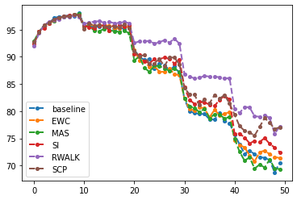

The matric is used to evaluating whether the methods are good or not while training from task1 to task5. It shows that RWALK is the best method in this case.

2.

loss = torch.sum ( output .pow(2) ,dim=1)

loss = loss.mean()

loss.backward()